Code of Ethics?
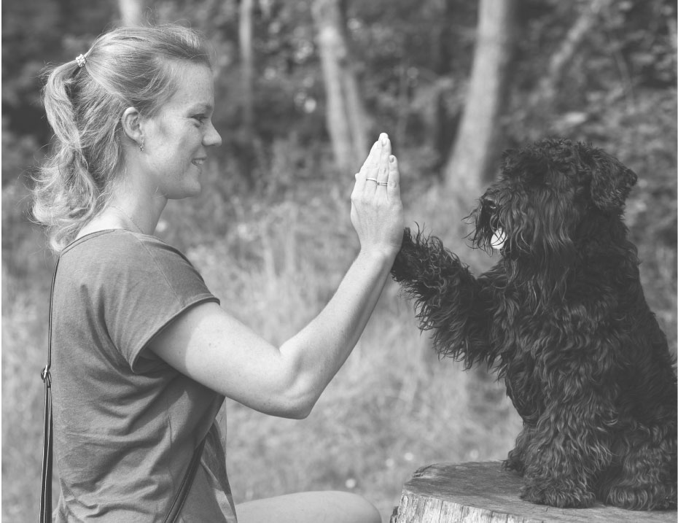

You should know…
The dog services—including dog training, dog waking, dog daycare, dog boarding, pet sitting, dog grooming, and similar services—comprise a young, largely unregulated industry. Anyone can hang a shingle and do business as they please, whether or not they have any experience or expertise. As a result, choosing the best dog businesses to care for your dog can be difficult and frustrating.

How to hire a dog pro
Here’s one thing to factor into your decisions: dogbiz invites only educated dog professionals committed to the latest science-based, humane training methods to take the ethics pledge.
Here’s another: Dog professionals who display the dogbiz Business Code of Ethics seal pledge to follow ethical business practices and offer superior customer service.

The dogbiz Business Code of Ethics
Dog professionals displaying the BCOE seal pledge to:
- Make no guarantees about behavior outcomes, as it is considered unethical in our industry to do so and is prohibited by the major professional associations; you simply cannot guarantee the behavior of another living organism. We recommend you carefully review any dog professional who offers such guarantees.
- Maintain clear written policies.
- Return phone calls and emails in a timely manner, and according to their outgoing messages.
- Fulfill their service obligations to you, and then go above and beyond when the opportunity presents itself.
- Use only positive, humane methods with all dogs in their care, and to uphold the same standards of interaction with you, their client.
- Listen to your needs and goals, then recommend the services that best suit you.
- Pursue continuing education and professional development in their field in order to be the absolute best at what they do.
- Maintain current business license, contracts, insurance and, where applicable, bonding.
Give yourself peace of mind: Work with a professional dog service provider. Choose a dog trainer, dog walker, pet sitter, dog daycare, or dog boarding facility who displays the dogbiz Business Code Of Ethics seal.
dogbiz is not responsible for the actions of individual dog professionals. You are responsible for fully vetting anyone you hire.

2018 dogbiz. All Rights Reserved

